

NAME – BIKESH KUMAR MAHATO

SECTION - K23EL

ROLL NO – 60

REGNO – 12326145

COURSE CODE – INT375

PYTHON CA 2 PROJECT

**Project Description: Mobile Phone Data Analysis**

This project aims to explore and visualize key trends within a mobile phone dataset using Python libraries such as **NumPy**, **Pandas**, **Matplotlib**, and **Seaborn**. The dataset includes features like brand, price, rating, RAM, screen size, refresh rate, and selling platform.

The analysis is divided into five focused objectives:

1. **Brand vs Price:** Analyzing the average price of mobile phones across various brands to understand brand positioning in terms of cost.
2. **Brand vs Rating:** Exploring the distribution of customer ratings for each brand to evaluate overall consumer satisfaction and brand consistency.
3. **RAM vs Price:** Investigating how RAM size affects the average price of mobile phones to identify value-for-spec trends.
4. **Platform Popularity:** Measuring how many phones are listed on each selling platform to determine which platforms are most commonly used.
5. **Screen Size vs Refresh Rate:** Examining the relationship between screen size and refresh rate to uncover display trends in mobile devices.

Each objective is visualized using a unique graph type to ensure clarity and enhance data storytelling.

**📌 Objective 1:**

**What is the average price of mobile phones across different brands?**

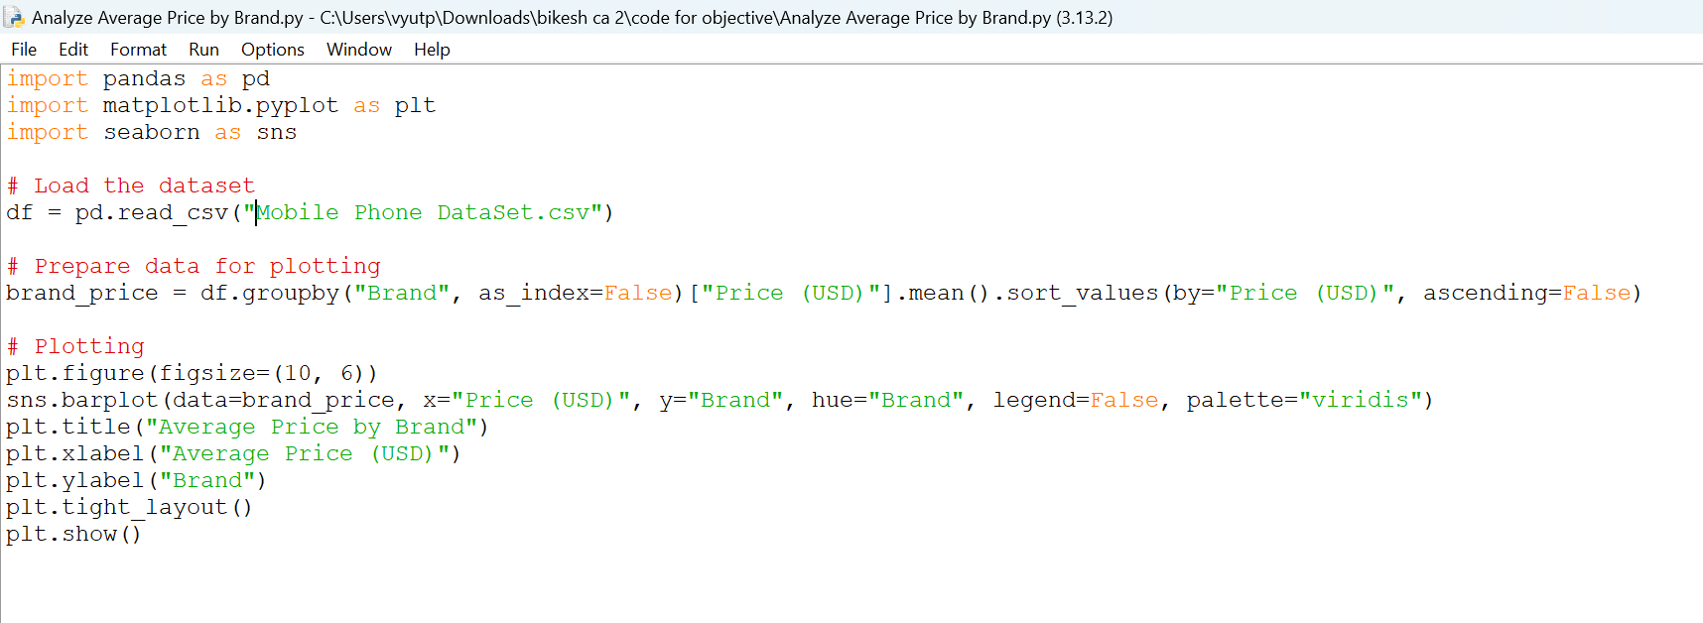

Output :

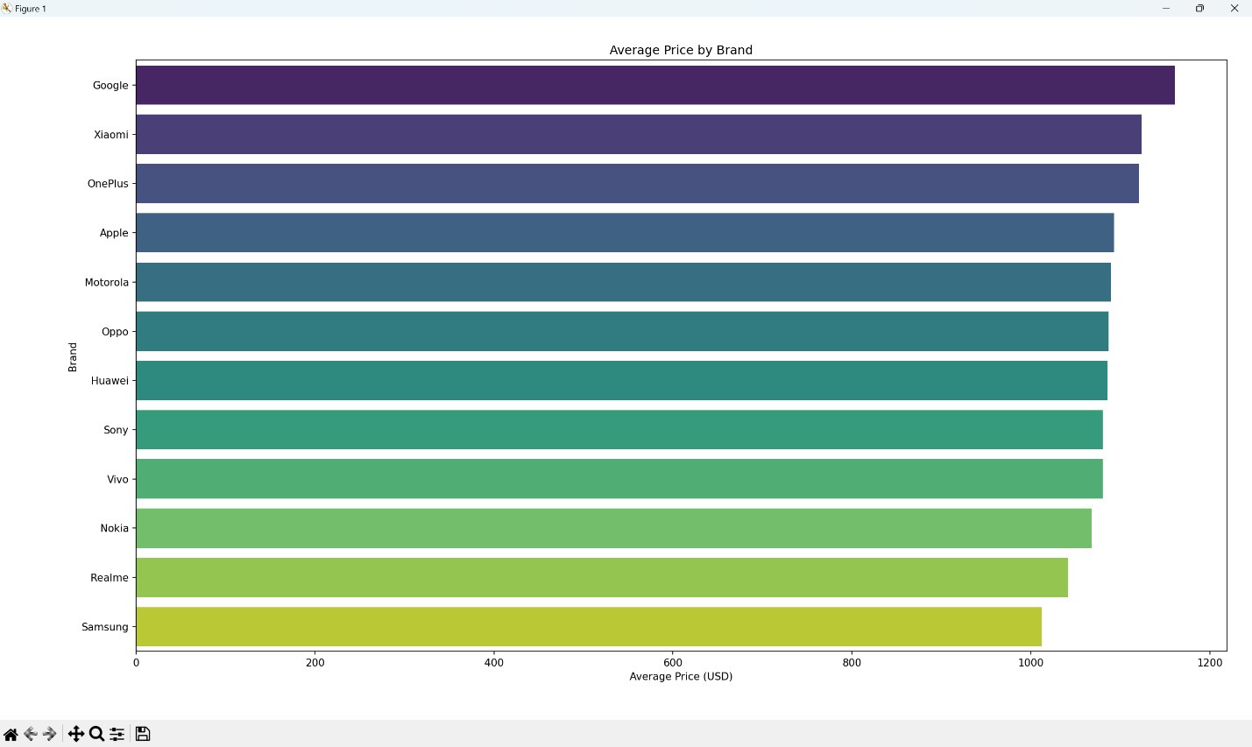

**📌 Objective 2:**

**How are customer ratings distributed for each brand?**

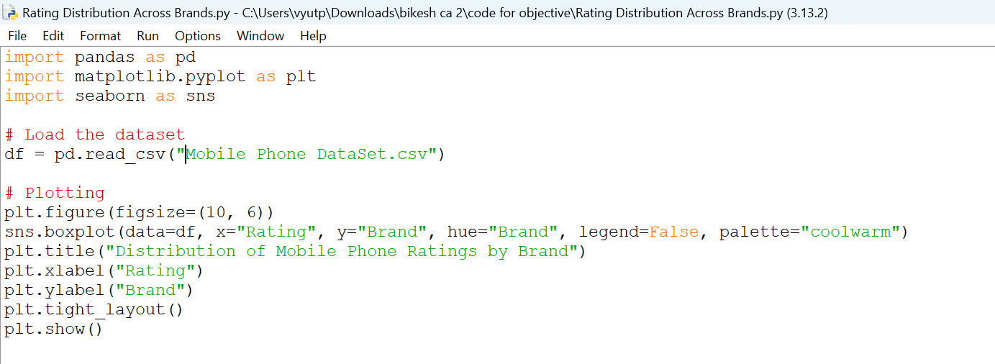

Output :

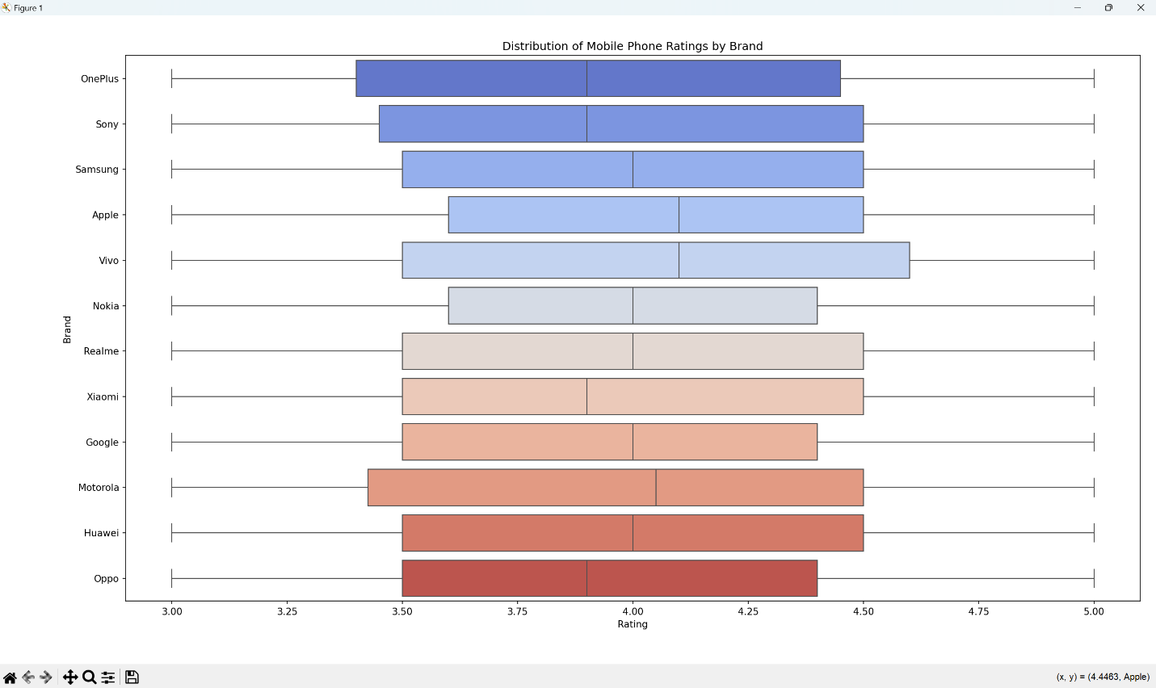

**📌 Objective 3:**

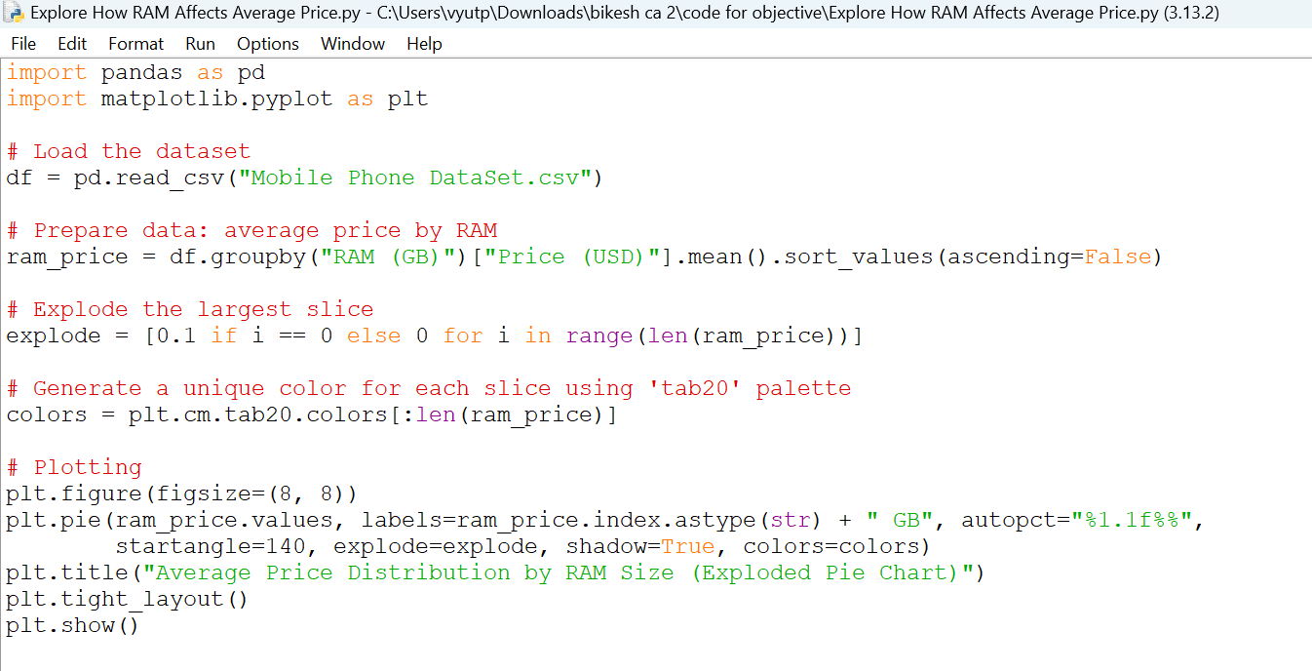

Output

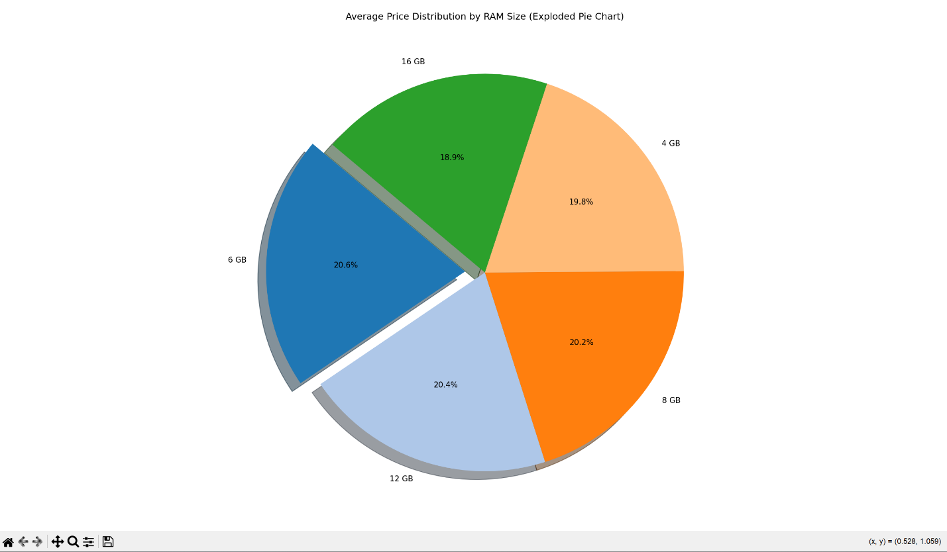

**📌 Objective 4:**

**Which selling platform has the most mobile phones listed?**

Output :

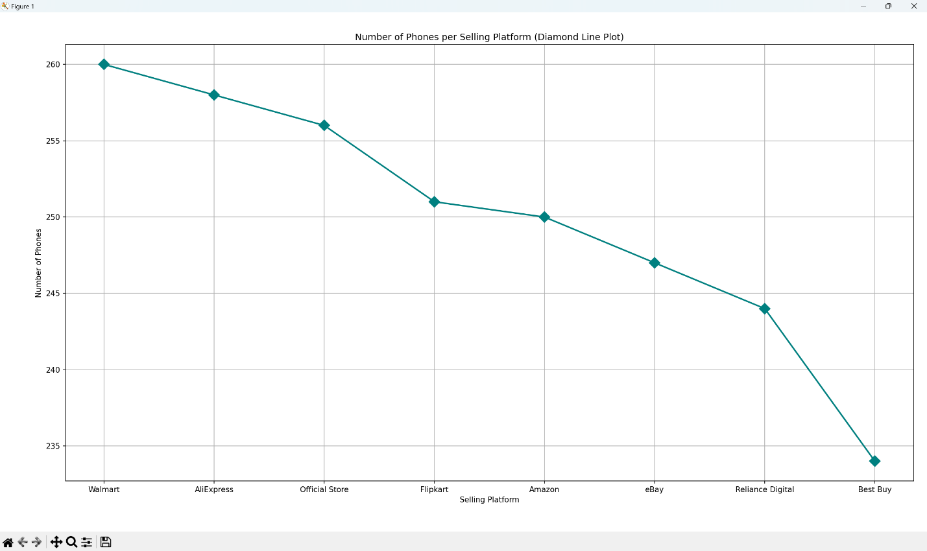

**📌 Objective 5:**

**What is the relationship between refresh rate and screen size in mobile phones?**

Output :

